**Uml Assignment**

**1.airline class diagram:**

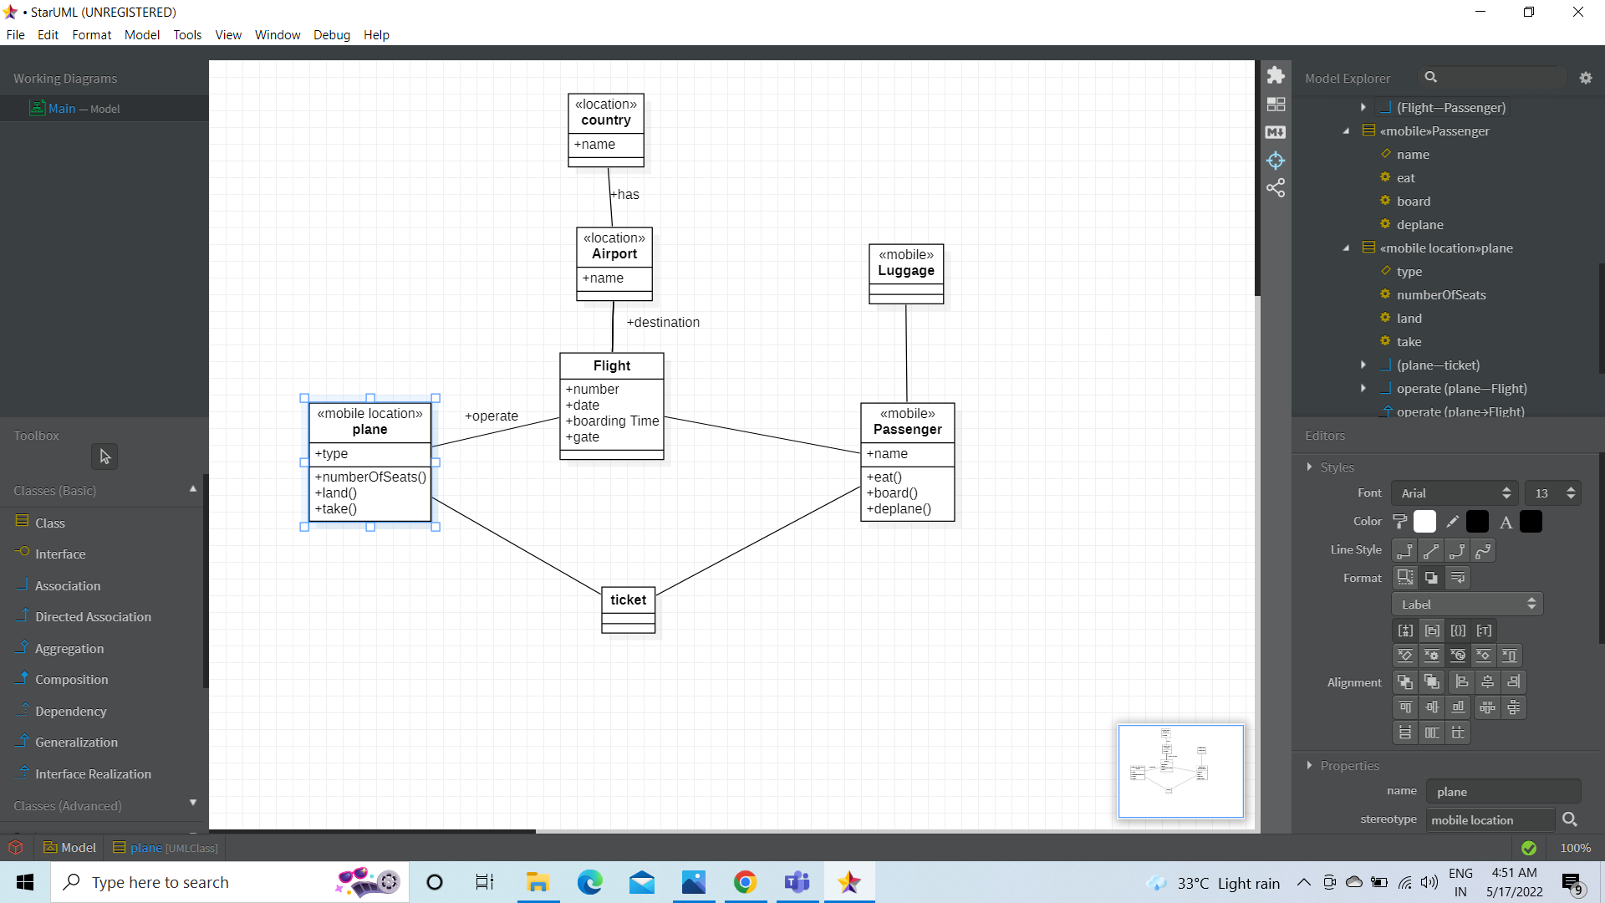

**2.class diagram for faculty management system:**

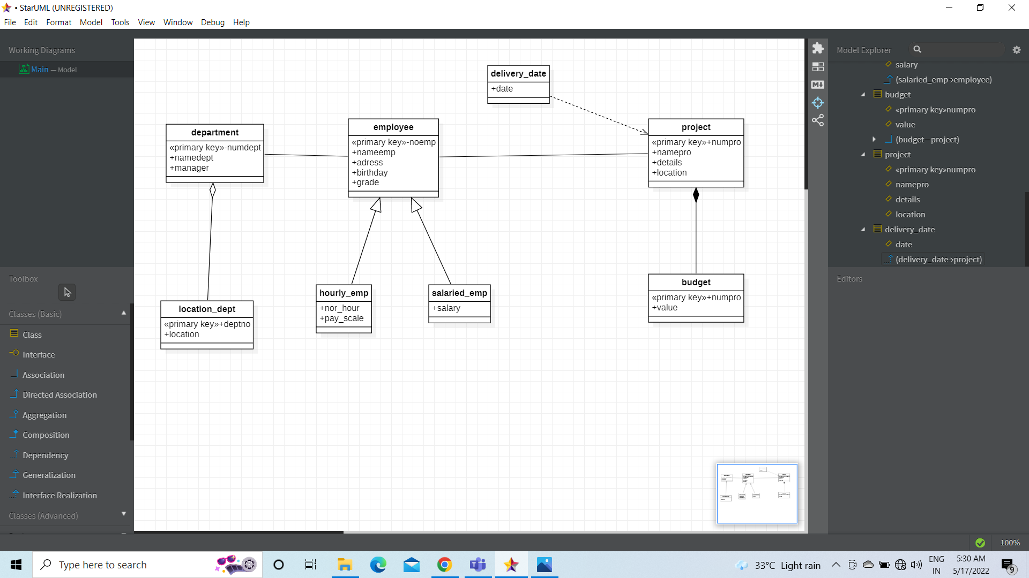

**3.Activity diagram for student enrolment:**

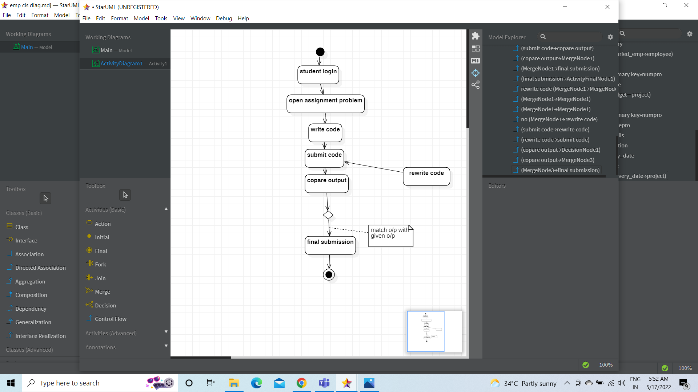

**4.sequence diagram for library management system:**

